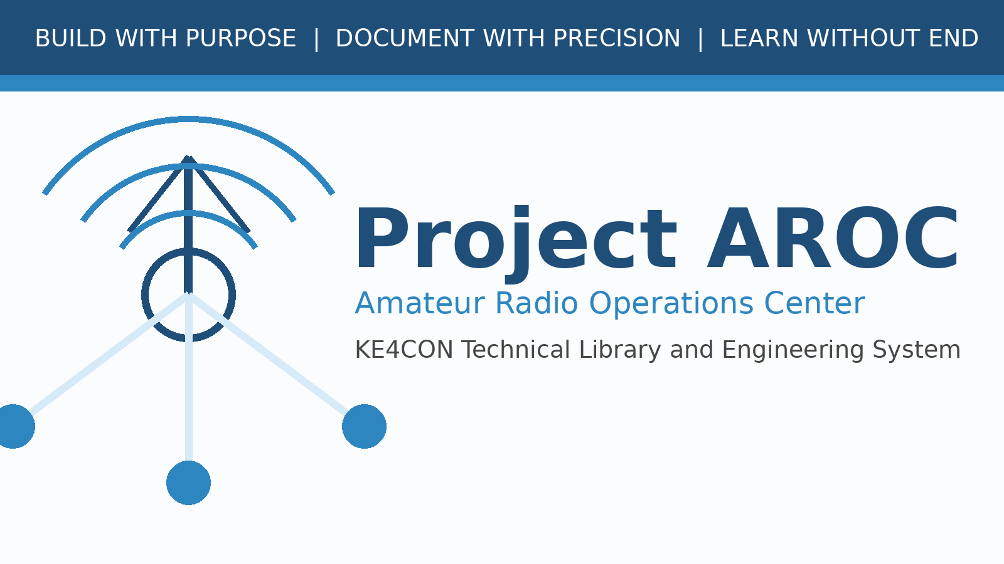

Project AROC Master Document Template
Reusable Template - Milestone 0003A

Document Number | AROC-TPL-0001
Revision | 0.1
Status | Draft for Review
Project | Project AROC - KE4CON
Motto | Build with Purpose. Document with Precision. Learn without End.

Document Control
Document Number | AROC-TPL-0001
Title | Project AROC Master Document Template
Revision | 0.1
Status | Draft for Review
Owner | James / KE4CON
Technical Author | ChatGPT
Applies To | Project AROC Technical Library and Engineering Documentation

Revision History
Revision | Date | Author | Description | Status
0.1 | 2026-06-30 | ChatGPT | Initial milestone 0003A publication framework draft | Draft

Instructions
Copy this template when creating a new Project AROC document. Replace placeholder text with the final document number, title, revision, and content.

1. Purpose
[Describe the purpose of this document.]

2. Scope
[Describe what this document covers and what it does not cover.]

3. Procedure or Standard
[Add the main content.]
Engineering Note
[Use this box for deeper technical explanation.]

Design Decision
[Use this box to record why a decision was made.]

Future Expansion
[Use this box for ideas that should be preserved for later.]

